The complete Remote Access software suite

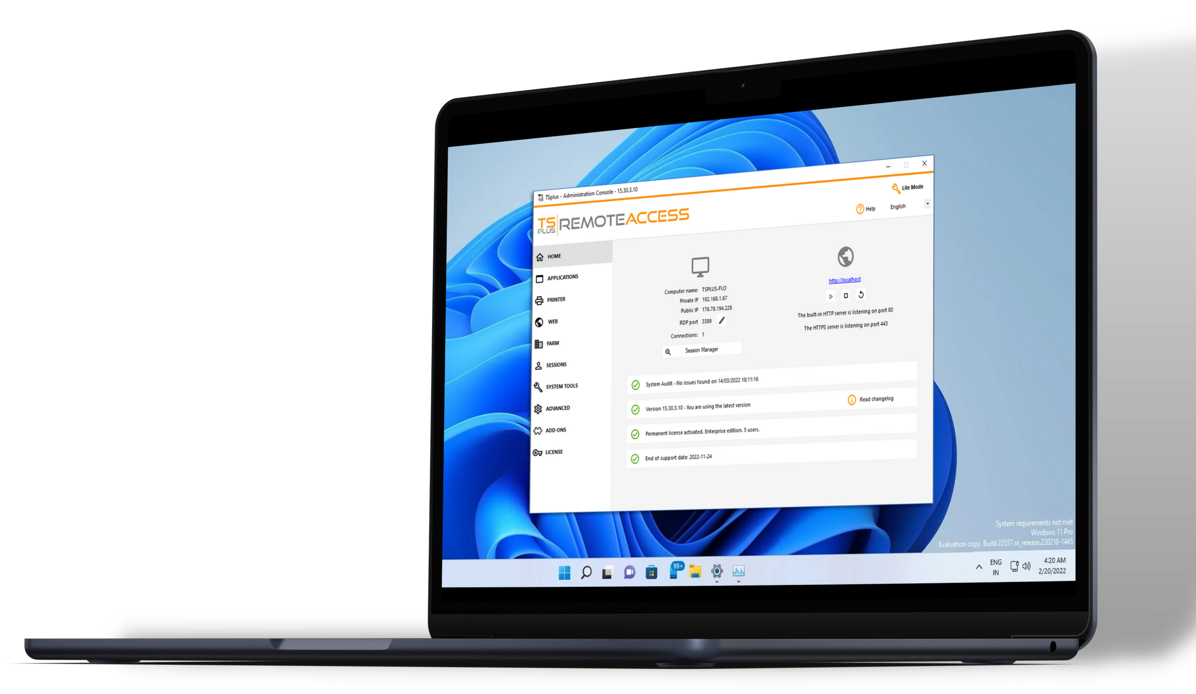

4 Remote Desktop and Application Delivery Solutions for IT Professionals. Our family of software covers a wide range of remote access needs with a core value: simplicity.

TRUSTED BY OVER 500,000 COMPANIES

2023
EDITION

AFFORDABLE TECHNOLOGIES
sales@tsplus.net
France, USA, Czech Republic, India
www.tsplus.net
BENEFITS FOR YOUR BUSINESS

FAST TO SETUP AND DEPLOY

USER-FRIENDLY INTERFACE
PERPETUAL LICENSES

SECURE CONNECTIONS

SCALABLE SOLUTIONS

Remote
Access
REMOTE ACCESS
Remote Desktop and Application Delivery

Secure, Scalable and Cost-Effective

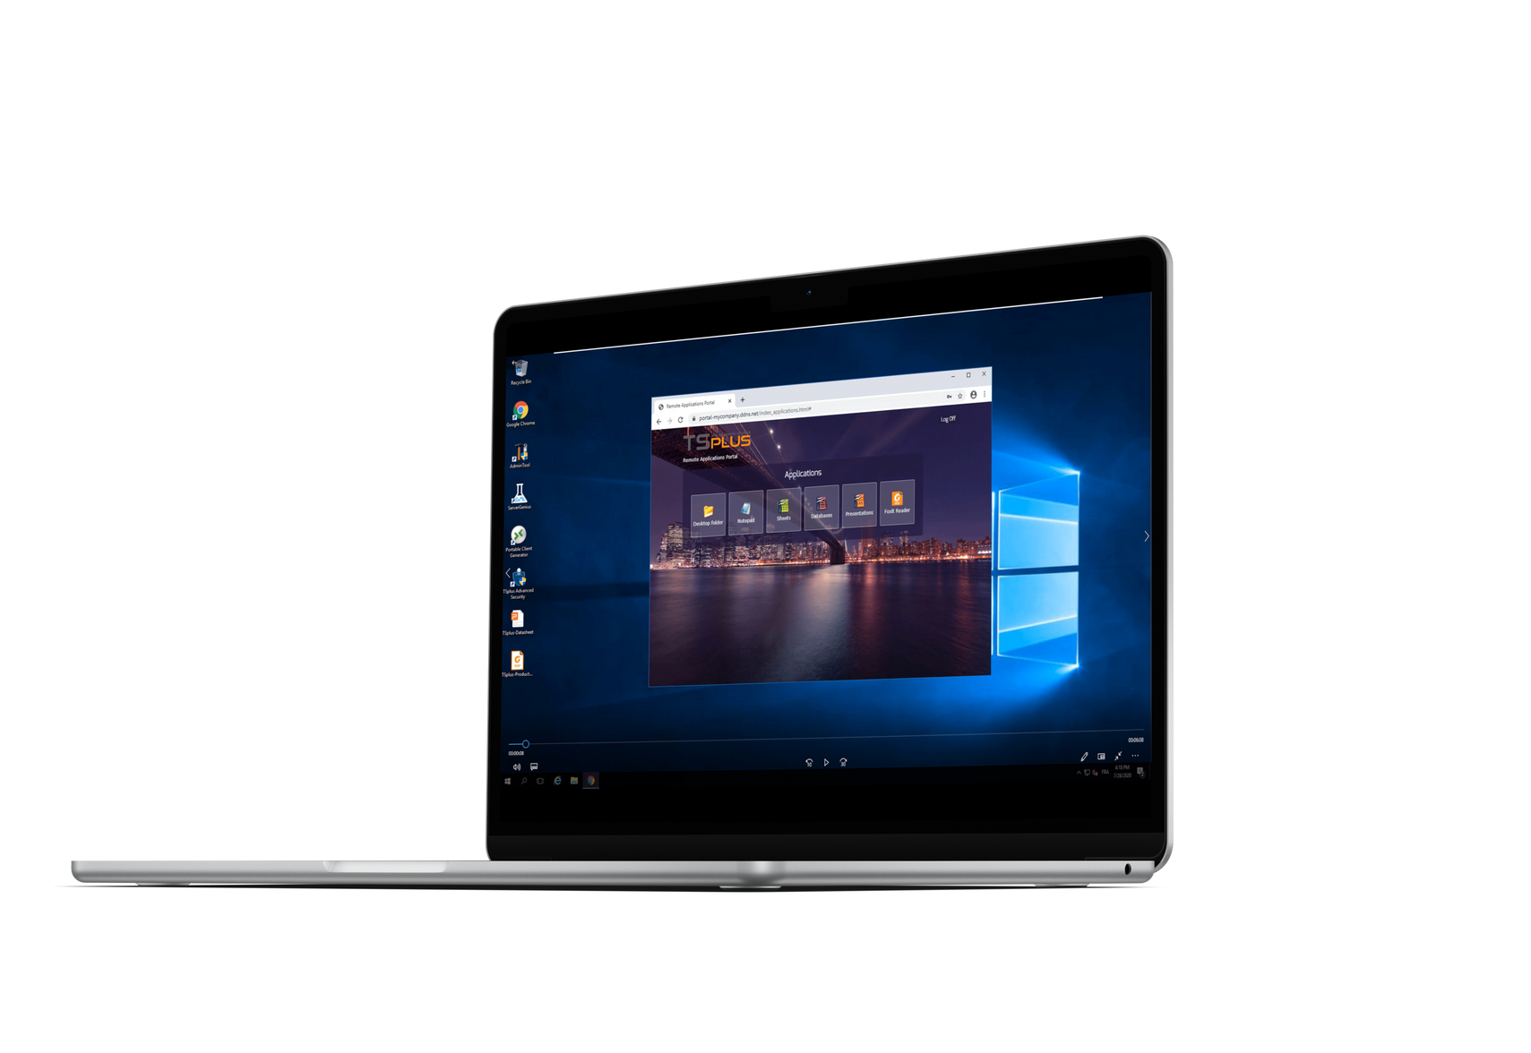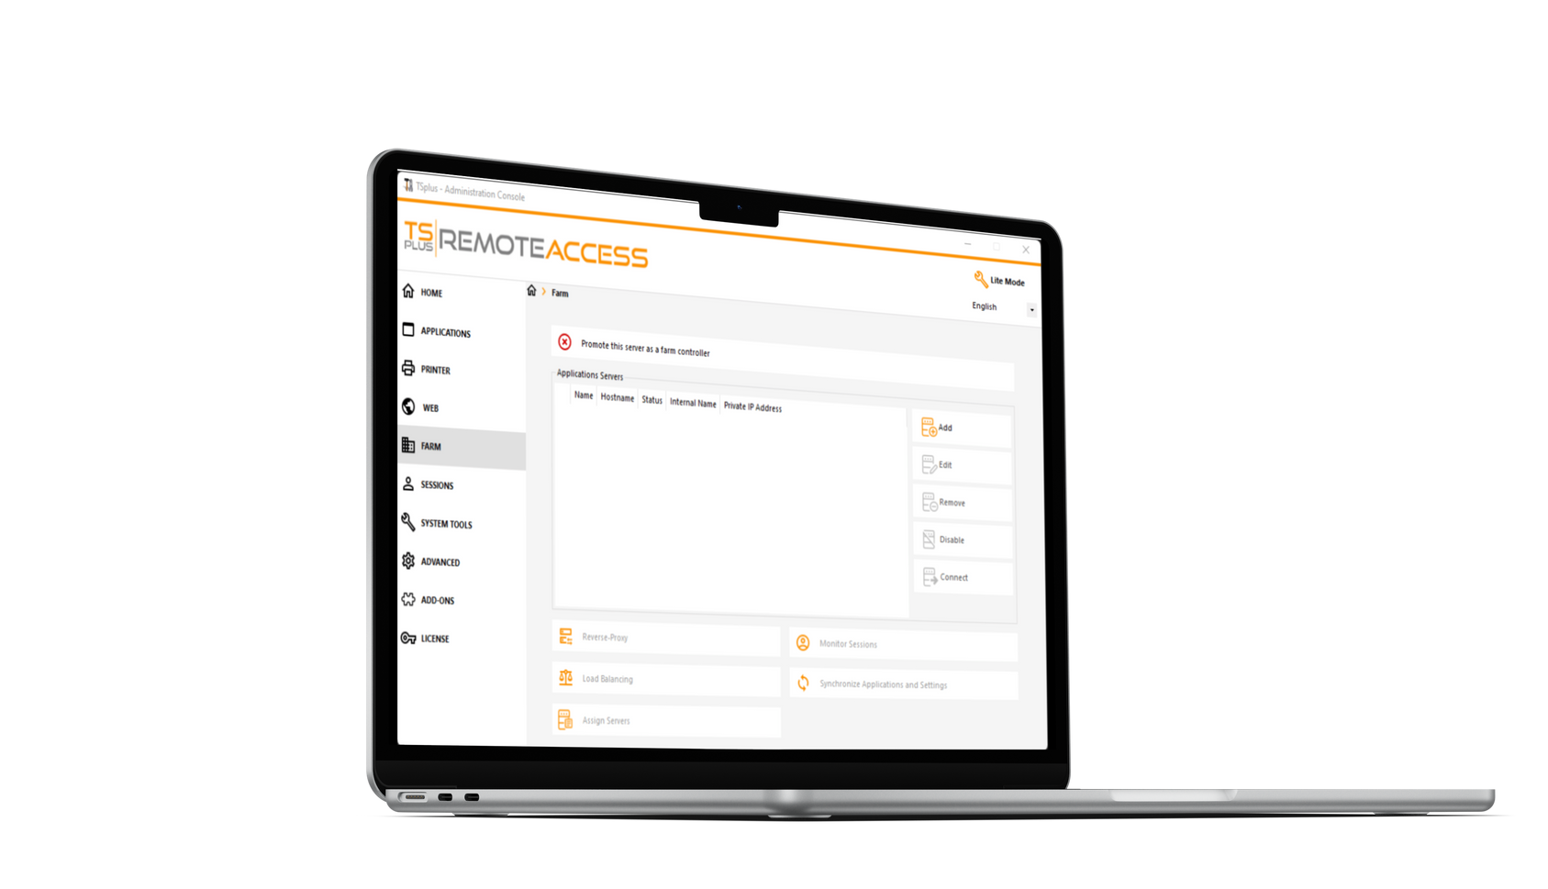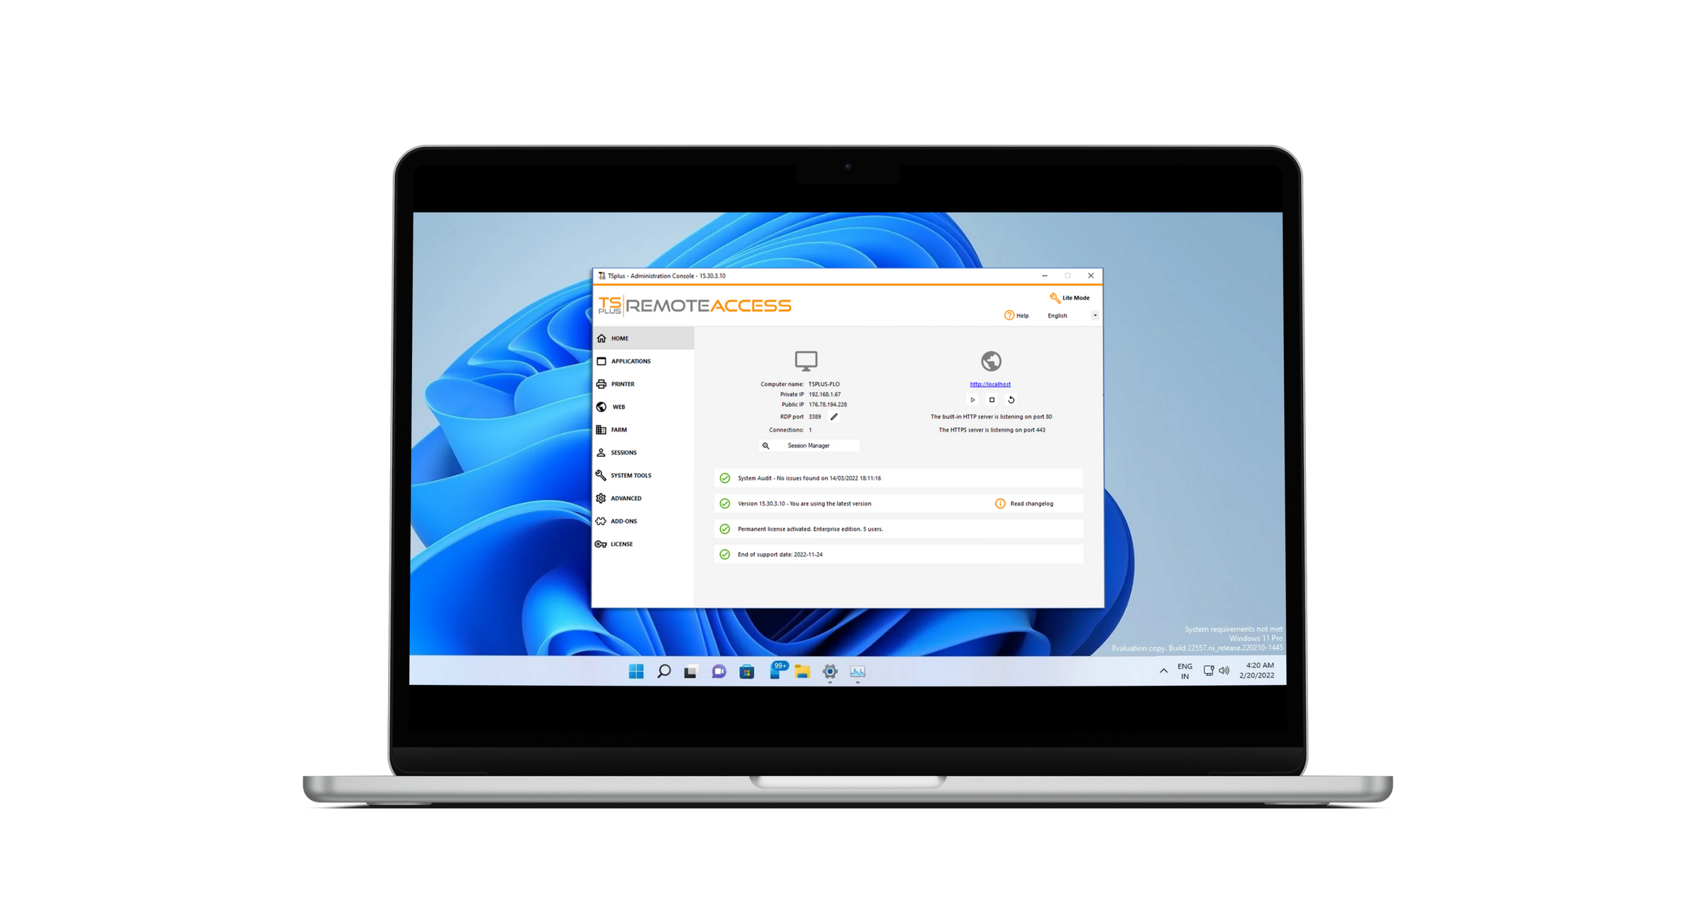
Secure Remote
Access
Web App Portal
Server Farm Management
Web-Enable Apps
Custom Solution
Enterprise Features

Publish Windows apps on a cloud or corporate server and give direct access to remote users on any device via RDP or HTML5 clients.
Various connection modes and settings available to build a secure remote infrastructure: 2FA, SSL encryption, remote printing...
Buy Now
www.tsplus.net/remote-access/
from $25/user
(UNLIMITED USERS - Desktop edition)
Advanced Settings adapted to the needs of large organizations: server farm, load-balancing, reverse proxy, gateway portal...

Advanced
Security
ADVANCED SECURITY

Remote Desktop Security

Sessions and Servers Protection

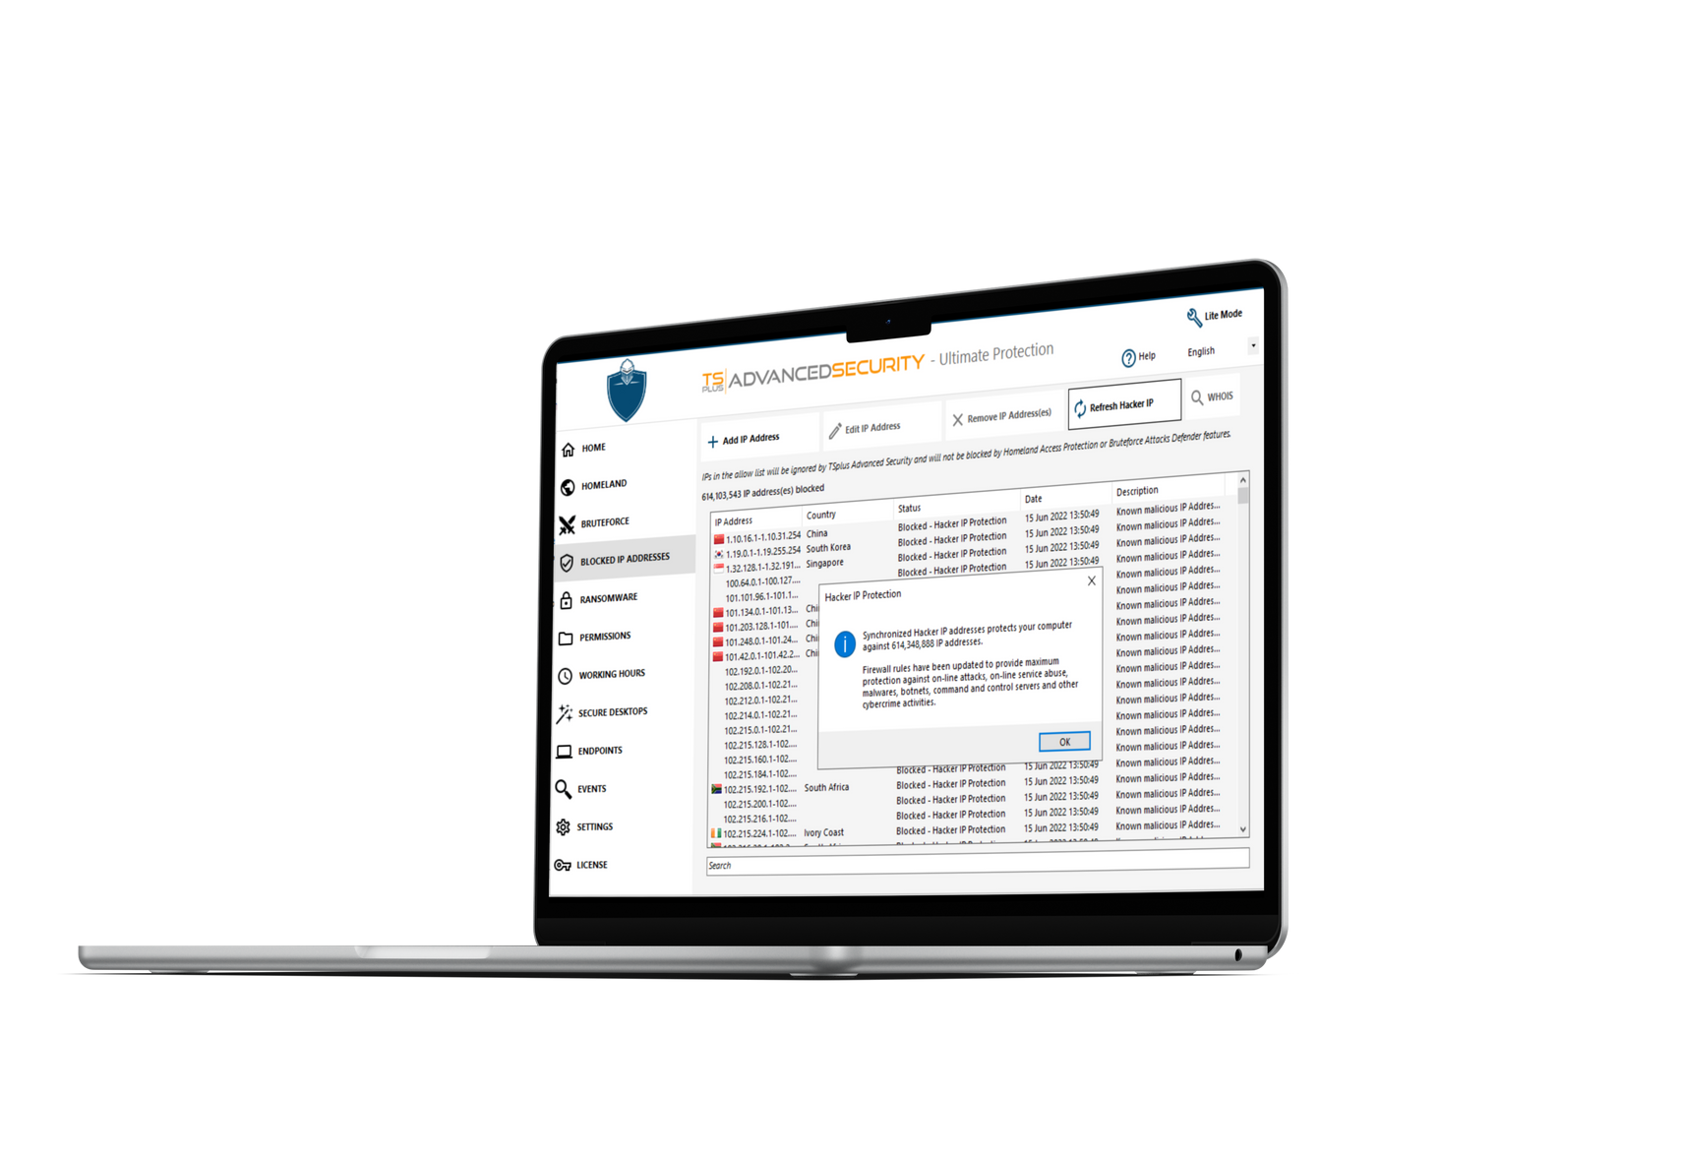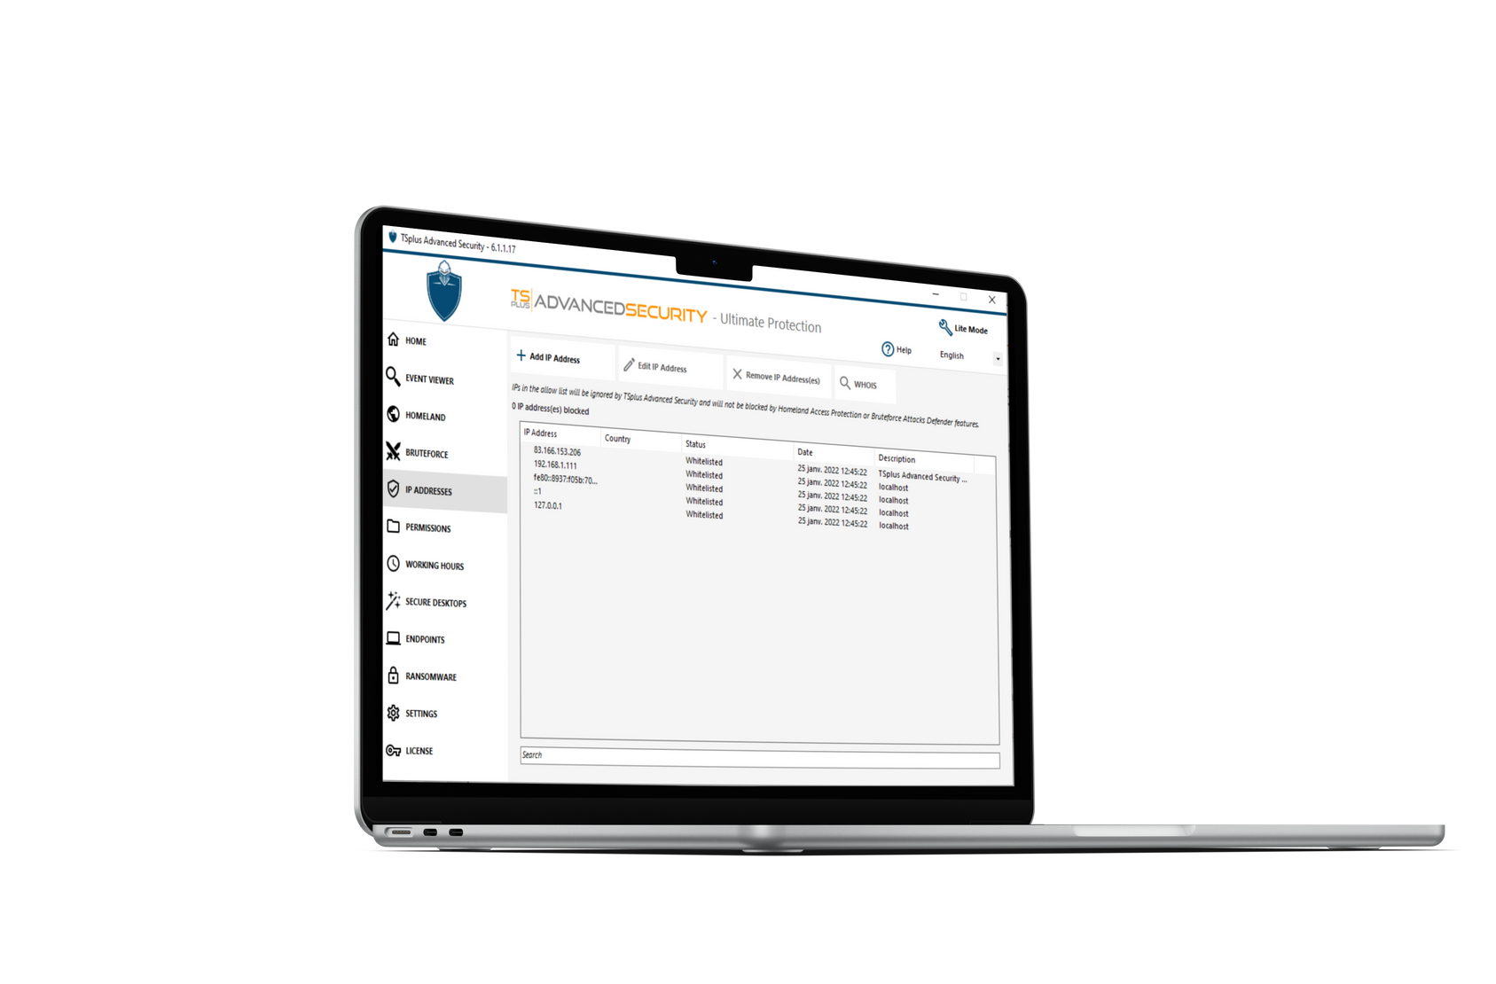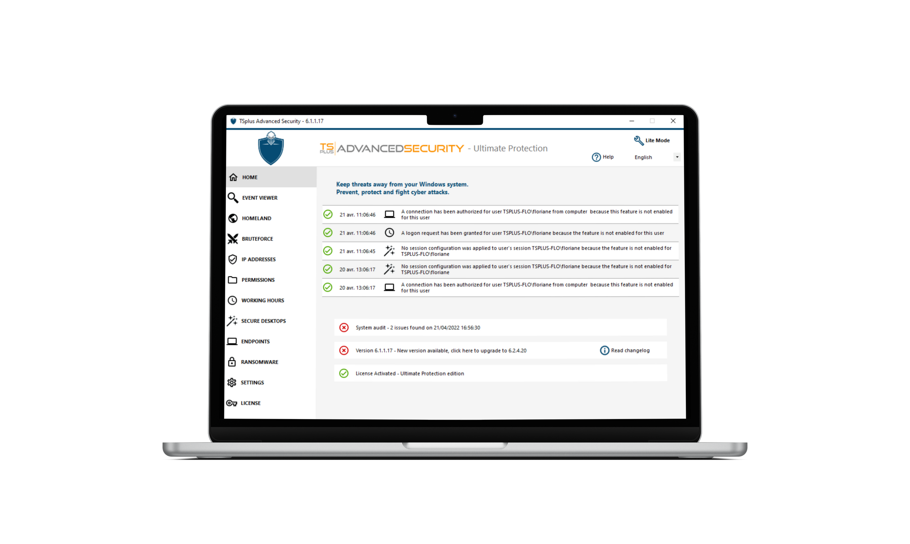
Access Restriction
Attacks Defender
User Rights Policies
Efficient from Day 1
Up to 7 Features
Easy Management

Buy Now
www.tsplus.net/advanced-security/
from $50/SERVER
(4 features - essentials edition)

Automatically blocks +600 million known hacker IP addresses. Monitors all risks and actions in the Event logs.

Limits connections by country, time of the day and devices. Blocks brute- force and ransomware attacks.

Easy to setup on a Windows server or desktop with a LITE mode available. Central IP addresses management.

Remote Support
Remote Support
Windows Session Sharing

Cost-effective and Secure

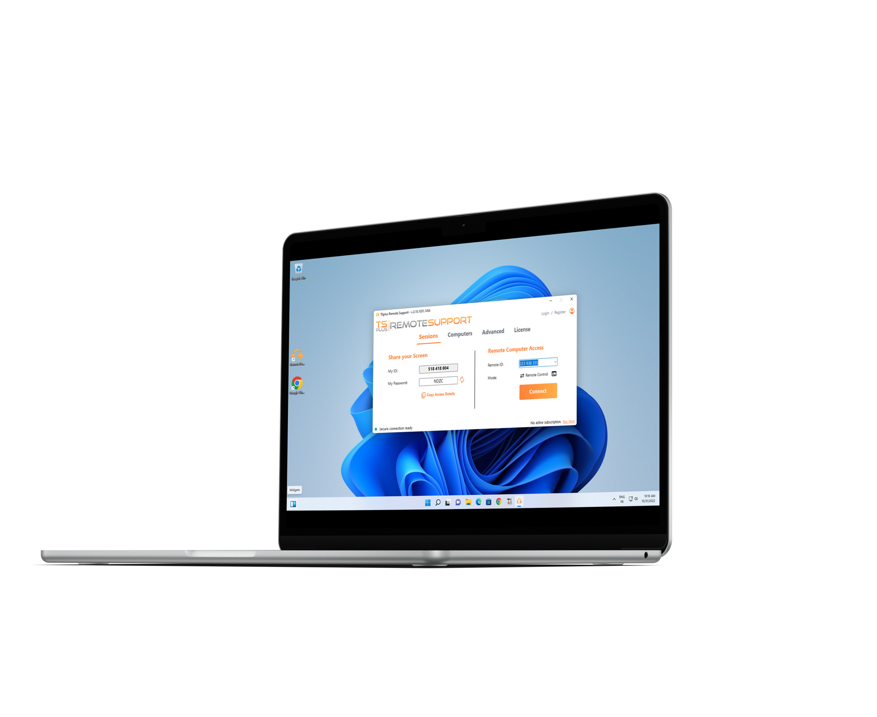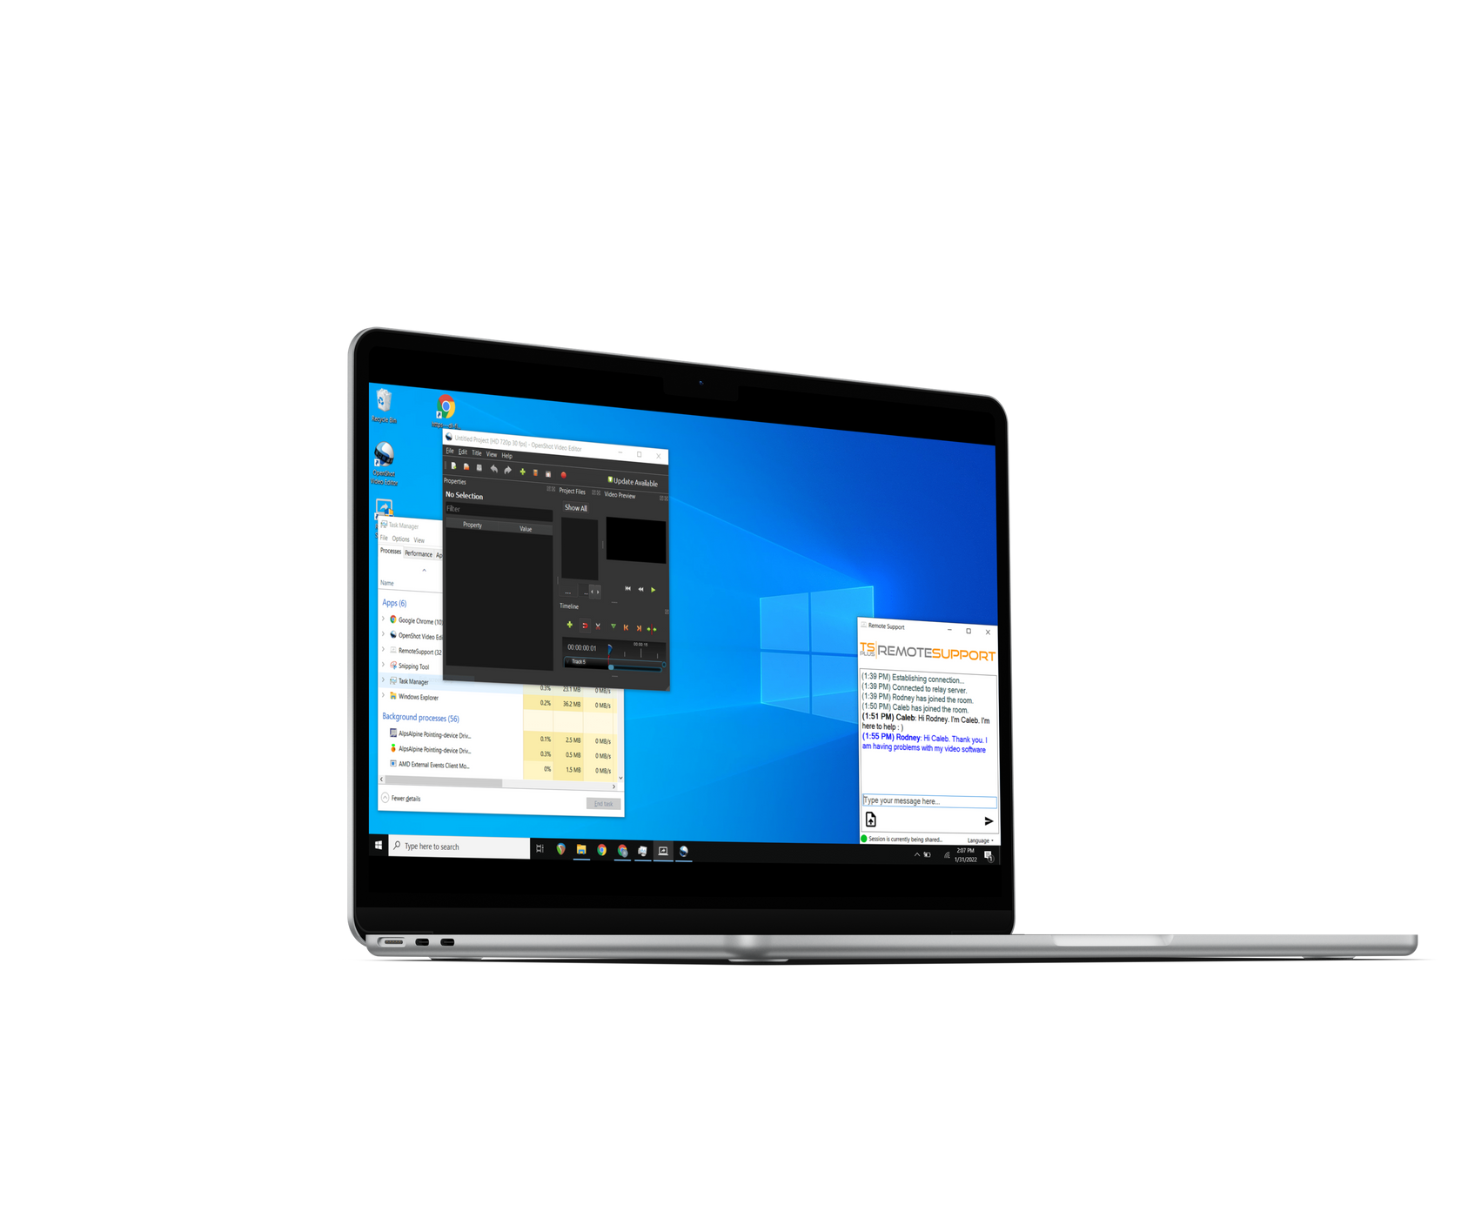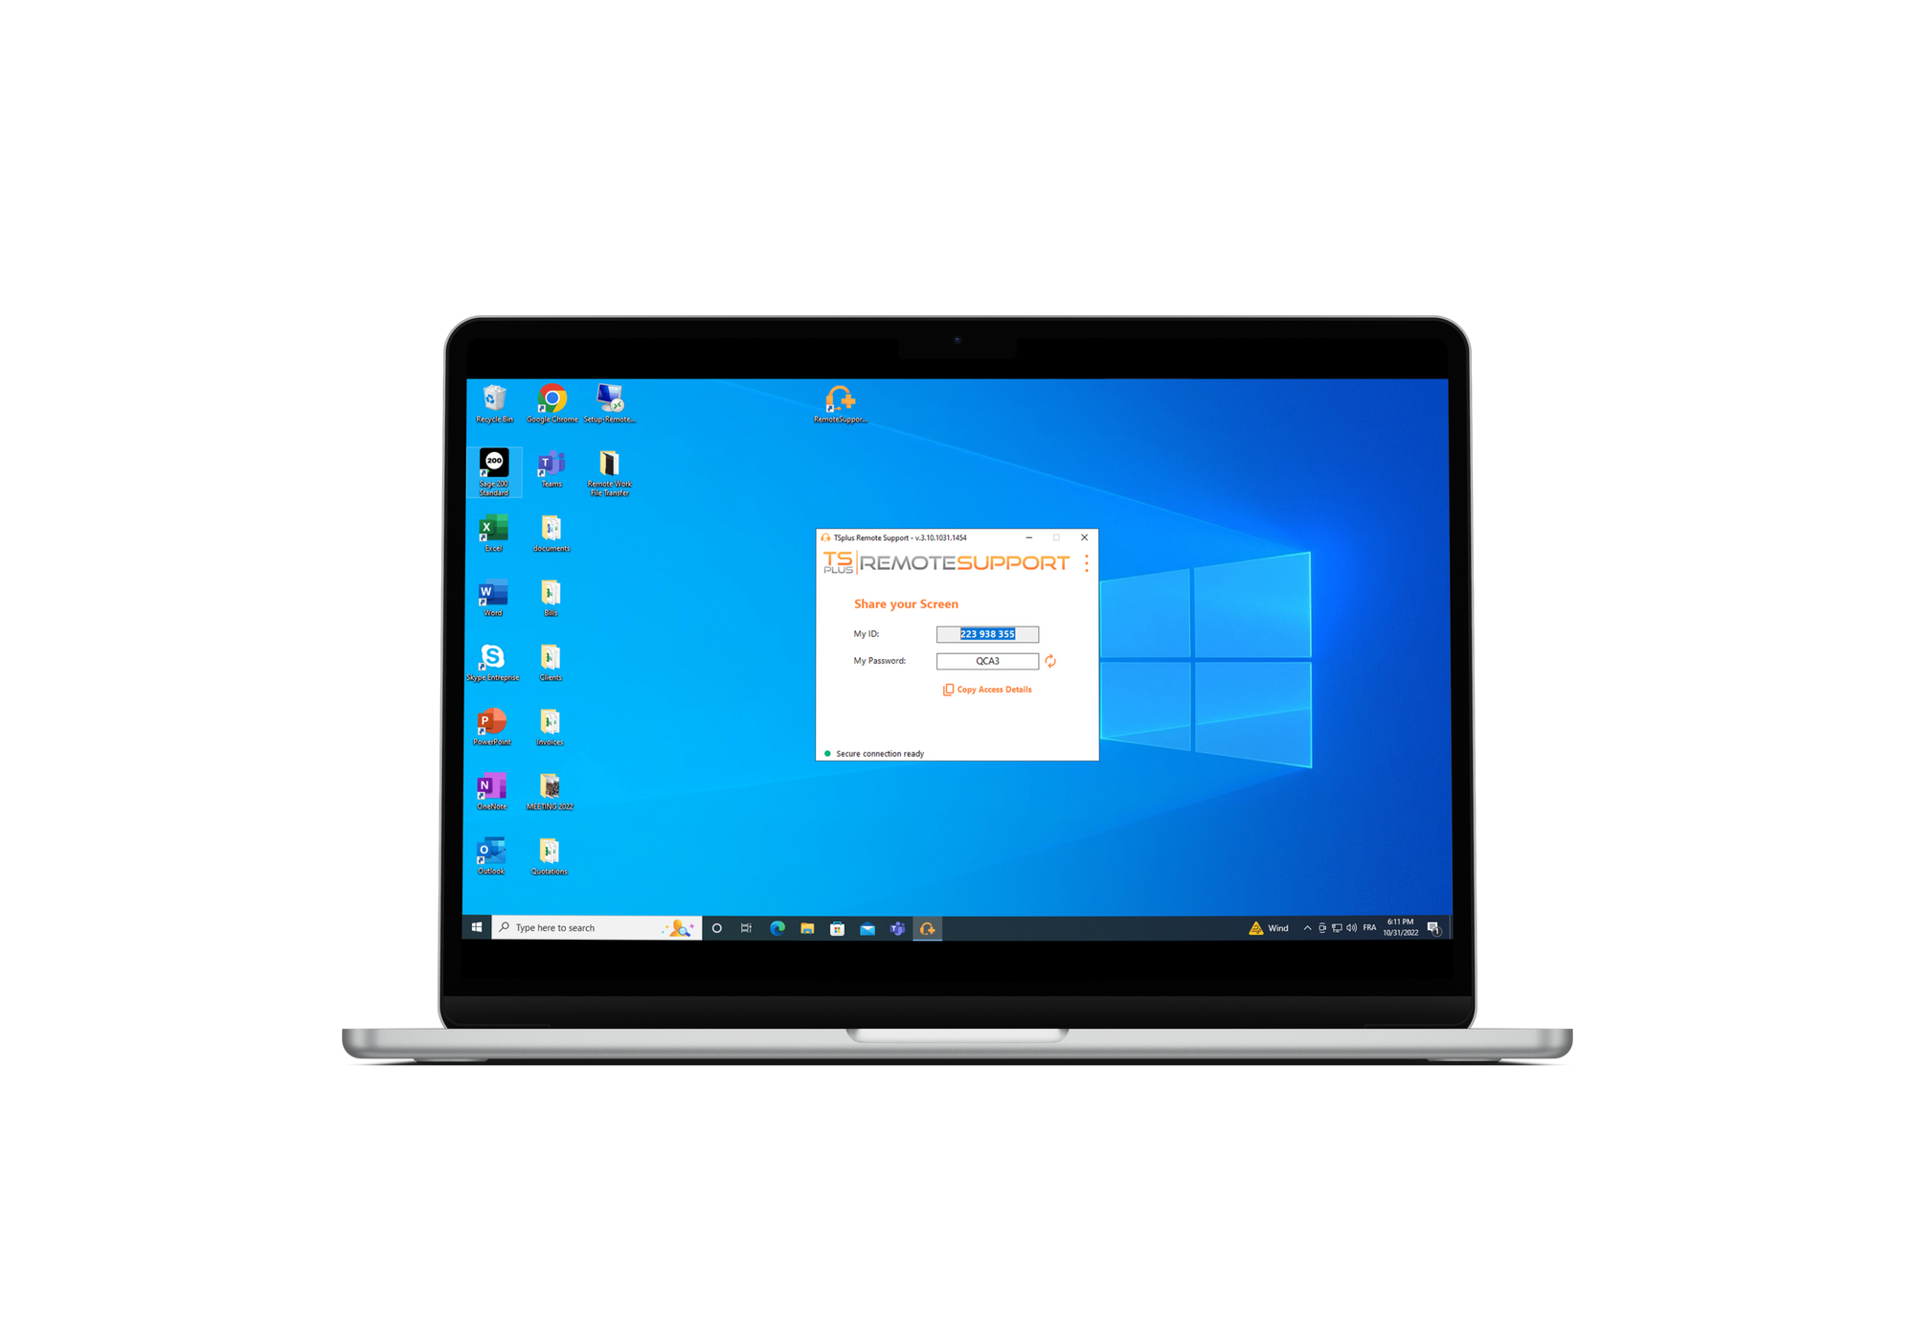
Remote PC Control
Screen Sharing
Unattended Access
Zero Installation
Quick Connection
Collaboration Tools

Small program to download and run on both sides. No setup needed.
Lite Connection Client. Session sharing in a click with ID and Password.
from $8/MONTH
(1 USER/ 1 concurrent connection - starter edition)
Chat box, file transfer, multi- agents connections, send command line, and more.
Buy Now
www.tsplus.net/remote-support/

Server Monitoring

Server monitoring

Server and Website Monitoring & Reporting

Comprehensive, Easy-to-Use, and Accurate

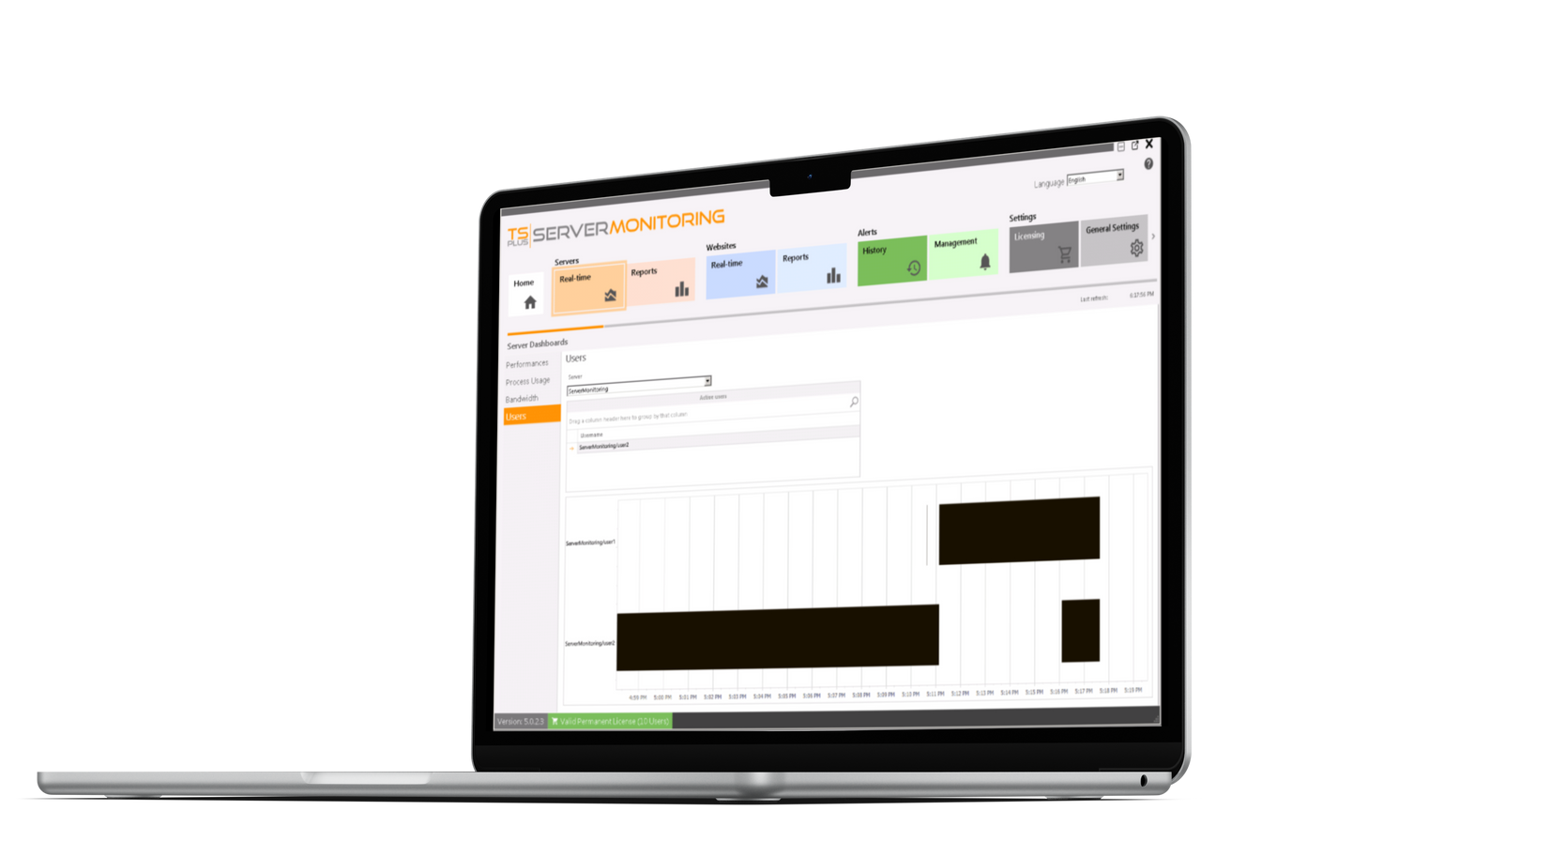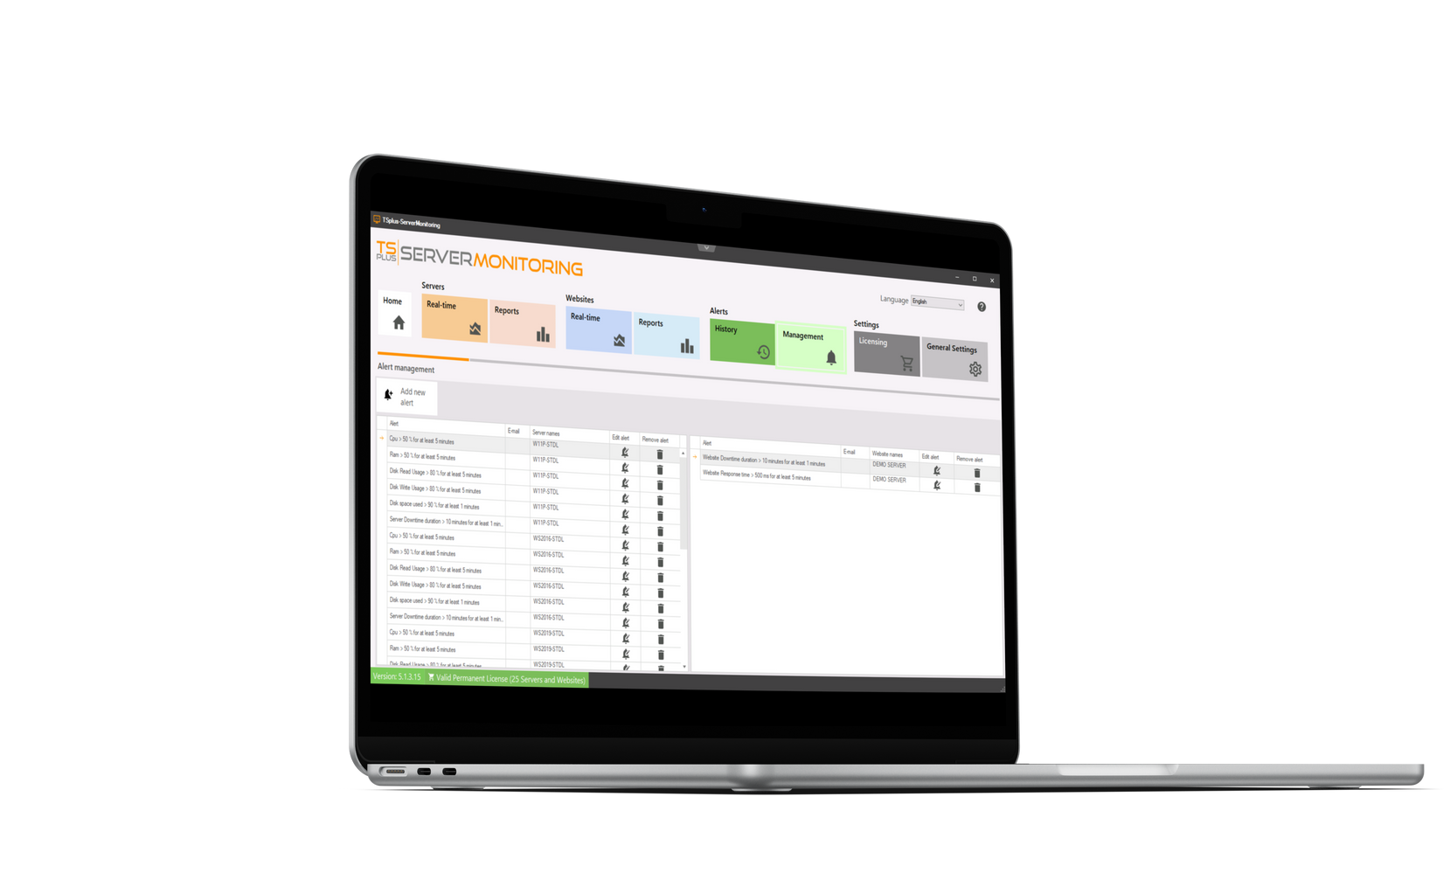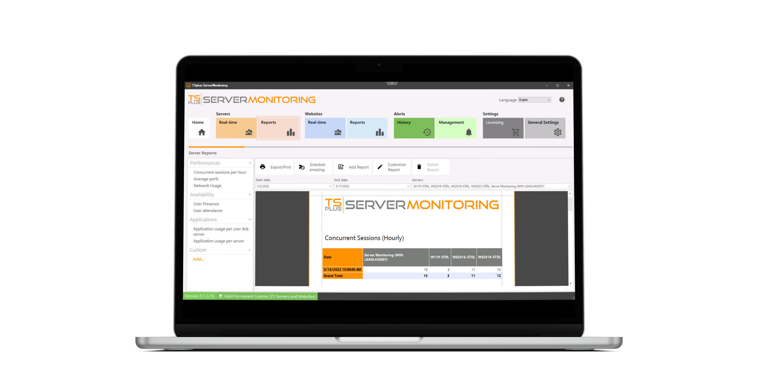
Real-Time Monitoring
Custom Reporting
Automatic Alert System

Remote Access Monitoring

Monitors all servers, websites, apps, and users of a remote work infrastructure from one place.
from $90 FOR 1 SERVER
(and 1 website - essentials edition)

Network Administration

Smart and easy-to-read reports with historical and real-time data about performance and usage.
Buy Now
www.tsplus.net/server-monitoring/

User-Friendly Tool

Add or remove servers in minutes, with customization options for reports and alerts (email & pop-up).

