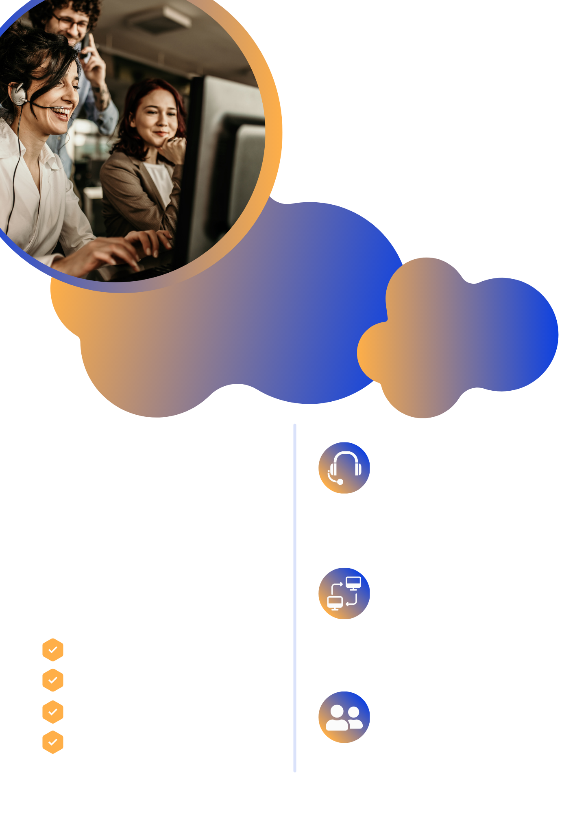

[WWW.TSPLUS.NET/REMOTE-SUPPOR](https://tsplus.net/remote-support/" \t "_blank)T

Simplified end-user interface with Lite connection client. Agents can enable dynamic screen resolution, multi-monitor support, and more

**User Experience**

Agents can easily add, connect, remove unattended computers, send remote commands and block user input capability

**Unattended Access**

One click to take control of the screen, mouse, and keyboard of remote clients to troubleshoot problems. With chatbox, file transfer, clipboard, etc

**Remote Support**

Connection with ID and Password

Branding options

End-to-end TLS encryption

No installation or configuration

About Us

TSplus Remote Support enables support agents and maintenance teams to provide instant, attended or unattended access to remote PCs, at a price that won’t break your IT budget.

Connection servers are fully managed by TSplus, with server locations all around the world.

**SECURE REMOTE ASSISTANCE SAAS SOLUTION**

REMOTE PC CONTROL & SCREEN SHARING