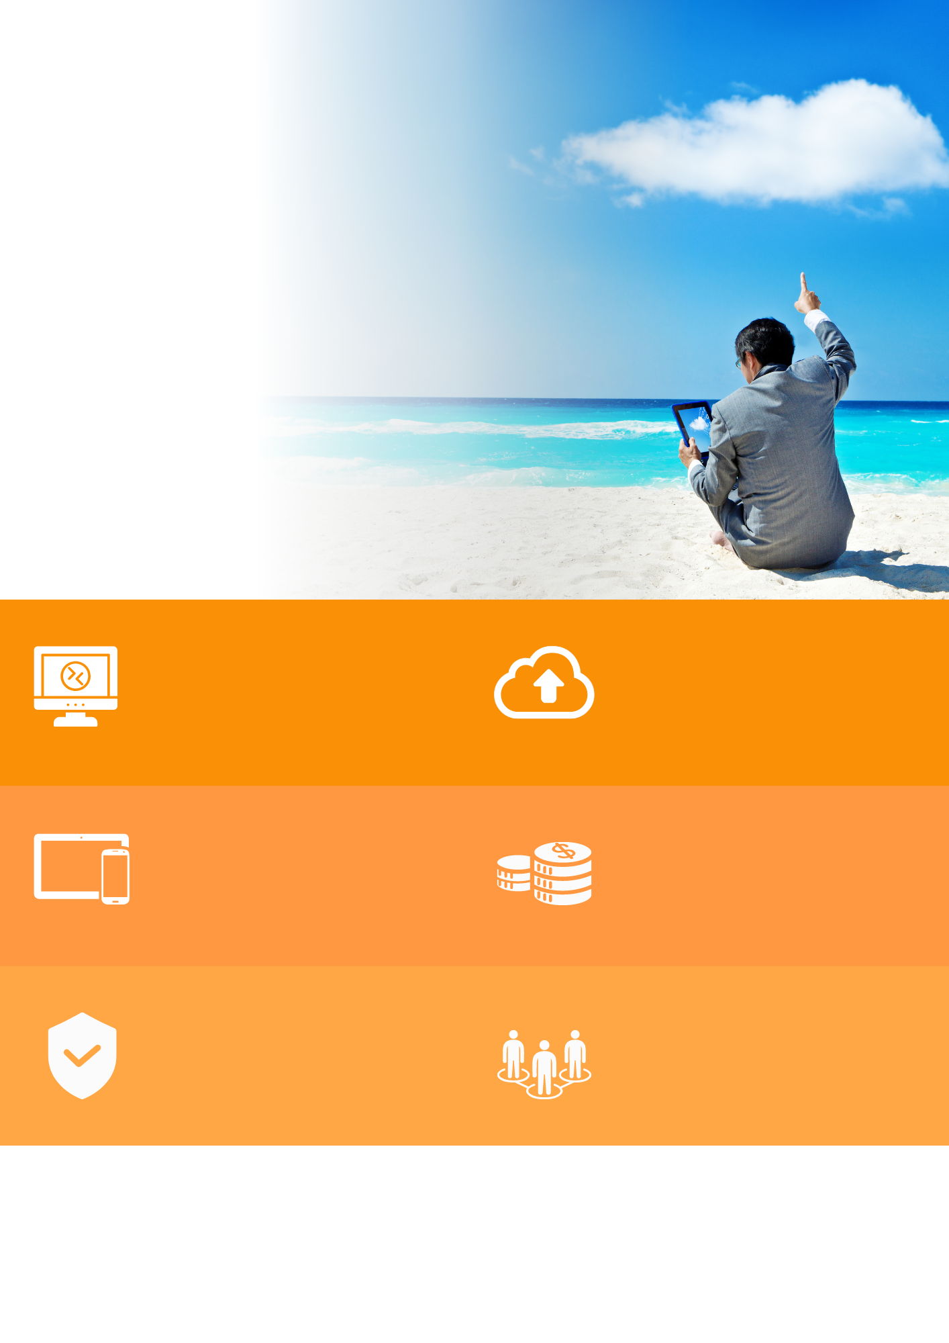

www.tsplus.net/remote-access

sales@tsplus.net

contact us

VISIT OUR WEBSITE

**web-ENABLE YOUR APPS**

**Optimize your IT budget**

**improve network mANAGEMENT**

**Secure your infrastructure**

**Deliver applications ON ANY DEVICE**

**ALLOW INSTANT remote access**

Centrally manage your servers Farm with advanced enterprise features such as reverse proxy and load-balancing via our intuitive Administration tool.

SSL-encrypt your remote connections. Add TSplus Advanced Security and TSplus 2FA to maximize your remote infrastructure security.

Create full desktops for users to remotely access centralized apps from anywhere and any device.

Extend the life of your legacy Apps by web-enabling them without redeveloping them. Keep your clients happy with your current UI.

Reduce IT cost by not redeveloping your apps or purchasing expensive alternatives. Our permanent licences last for life.

Publish your Windows Applications to deliver them seamlessly to the remote devices of your users, including PCs, Macs, smartphones and tablets.

"Instantly share your Windows Apps anywhere"

Discover the ideal alternative to Citrix and Microsoft RDS for remote desktop access and Windows application delivery.

Remote Desktop

and web portal